**Exp 3 oose**

**1 INTRODUCTION**

1.1 Product Overview

E- banking system software is designed so that the user can access his/her bank account from anywhere. It will be more efficient and easier way to have a record on systems through which everyone can easily access it according to his rights as compared to the traditional banking system.

**2.1 External Interface Requirements**

**2.1.1 User Interfaces**

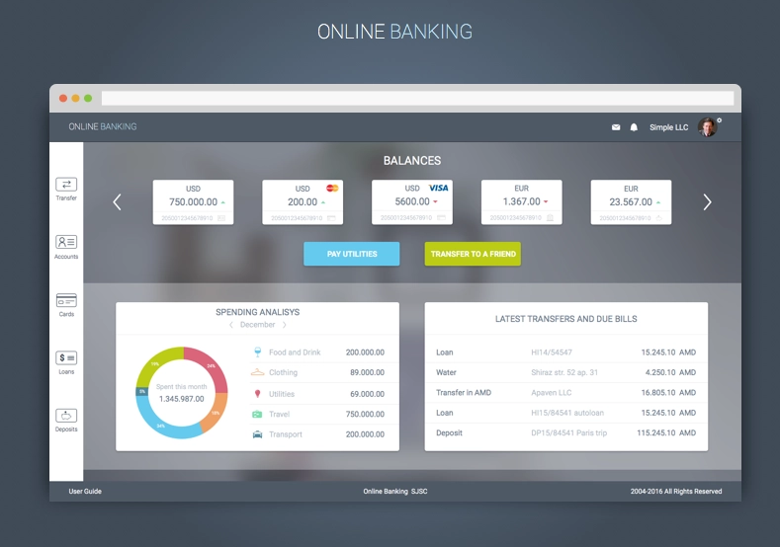

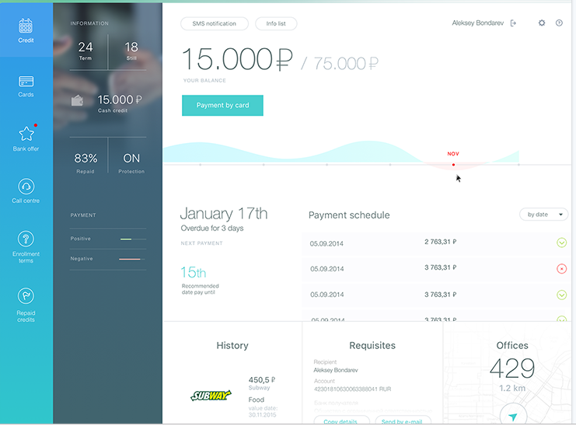

**2.1.2 Hardware Interfaces**

As this system is an online Web-based application so a clientserver will be the most suitable Organizational style for this system.Computer systems will be needed by each of the actor as well as that usermust be connected to the internet.So, concisely following hardware will be needed.

1) Computer systems

2) Internet availability

**2.1.3 Software Interfaces**

Client Side: HTML, Web Browser, Flash Player, MS angular-js,react , JavaScriptOffice .

Web Server: HTML, Mongodb , firebase ,node.js , express , route handler , firebase cloud function.

**2.1.4 Communications Protocols**

The Customer must connect to the Internet to access the Website:

1. Dialup Modem of 52 kbps.
2. Broadband Internet.
3. Dialup or Broadband Connection with a Internet Provider.

**2.2 Software Product Features**

Customer will be able to check his balance online while sitting at home by accessing the database of the bank using his/her password and account no.allotted to him provided by the e-bank. It will be easy for the customer to view or save his history transactions up to past 1year transactions. It will provide him the opportunity to maintain his bank balance and needs.

**Functional Requirements:**

* **Customer :** The requirements of the valid customer are offered.
* **Login** : A customer to be able to use this system, he/she has to enter username and password which he/she has created before and been saved in the database in the Login page. The input in this function most be valid username and valid password and the output if the user is valid user then he/she will get into a page which can makes has/her transaction, but if the user made wrong in username or password then he/she will be invalid user and will see a message “Alert Invalid Username and Password” and to login again.
* **View Account** : View Account allows to a customer to view today’s up-to the minute balance information on deposit (saving/current), credit card, etc. But the customer most be logged in the internet banking.
* **Pay Bills** : The customer most be logged into Banking System. With internet banking, customers can make payments to corporations that include utilities, assessments, Insurance, telecommunications, and other services. The customers can use Online Pay Bill service to pay bills by debiting their account. The customer needs to key in his/her bill account number each time you make a payment.
* **Authentication :** When logging in, users commonly enter usernames and passwords for authentication purposes. This login combination, which must be assigned to each user, authenticates access. However, this type of authentication can be circumvented by hackers.So in order to avoid this verification of user presence is performed by sending OTP to the registered phone number/mail account etc. This makes it more difficult for hackers to break into systems.
* **Authorization levels :** A user can authorise transactions up to his/her daily limits and/or transaction limits. Different staffs are assigned different levels of access to user accounts.
* **Legal or Regulatory Requirements :** The most important rationale for regulation in banking is to address concerns over the safety and stability of financial institutions, the financial sector as a whole, and the payments system. Mandatory deposit insurance schemes are introduced in order to avoid bank runs.
* **Transaction History :** After the user has logged in , he/she can view the transaction history. the system will show the View Account page and display a message” Please click on the respective account/card types for more details. Customer can choose current account or saving account for more details.
* **Apply for extra bank features:** unique features to their accounts tab along with the usual ones:
* **Set a saving goal** — User can set a desired amount and a time by which they want to save it.
* **Make an investment** — User can place an investment order if they have an investment account.
* **Make repeat payments** — If Users have already sent money to a friend or family member, they can tap on a previous transaction and send money again without entering any recipient data.
* **Intelligent chatbot for customer support** --  A chatbot can easily answer hundreds of customers at the same time without making them wait in line.

**2.3.1 Reliability**

The user will be assured that the documents and the transactional reports uploaded by the user will be saved and secured in the database. No other user can access or read other users data unless permission granted.

2.3.2 Availability

The degree to which users can depend on the system to be up (able to function) during “normal operating times”. The System shall be available for use between the hours of 6:00 a.m. and 11:00 p.m. IST(when registering for the first time and the time limit for token genetrated is 2 mins ).

2.3.3 Security

The degree to which the software system protects sensitive data and allows only authorized access to the data. Security Number shall never be viewable at the point of entry or at any other time.Only the last four digits of a SSN will be displayed on printable electronic documents.

2.3.4 Maintainability

The ease with which faults in a software system can be found and fixed.

2.3.5 Portability

Highly portable software can be accessed by computer laptop or mobile devices.

2.3.6 Performance

The online banking system is a multi- user system, which implies distinctive clients can access the system simultaneously and the system will work accurately and proficiently. So the client is more worried about the performance of the online banking. The term performance suggests the ability of the system or software to process the same number of transactions every second as submitted to it without failure.

2.4 Database Requirements

